|  |  |  |  |
| --- | --- | --- | --- |
| **Module** | **Requirements** | **Test** | **Acceptance Criteria** |
| **Obstacle detection/anticipation** | Sensors should measure distances accurately | Place obstacles at 4 different distances(3cm, 1m, 2m, 3m) away from the sensors | Computed distances match the measured distances within ±2.5% error |
| Blind spot Coverage | Mount the sensors on the remote controlled (RC) car to cover the defined blind spot (Appendix F); place obstacles within it | The sensors detect the presence of the obstacle within the defined range |
| Microcontroller should compute relative speed based on distance values | Mount sensors to the RC car; place an obstacle and the RC car in motion with a known relative speed | The microcontroller’s calculated speed values match the known value within ±5% error |
| Obstacle Anticipation | Set up situations where both distance and relative speeds are known, and perform allowed time calculations with the microcontroller | The microcontroller’s time values match the calculated ones within ±12% error |
| **Output** | The Light Emitting Diodes (LED) and the display should provide accurate feedback to the user | Observe the feedback response of the LED and the Liquid Crystal Display (LCD) display | The LED should behave according to the defined look-up table (Appendix H); the display should contain calculated values of distance to obstacle; relative speed, and time left for a lane change |
| **Automation** | The steering of the RC car should lock when necessary | Simulate the extremely dangerous, and very unsafe cases (Appendix H) | The steering of the user car is irresponsive in the direction of the obstacle |

Distance Tests:

5cm

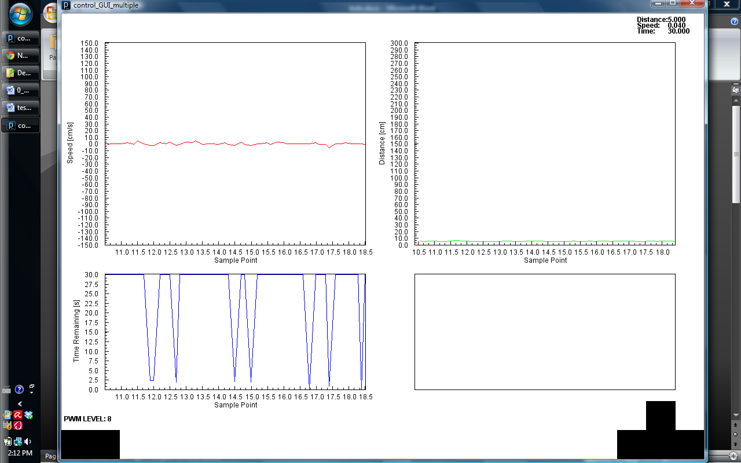

1m

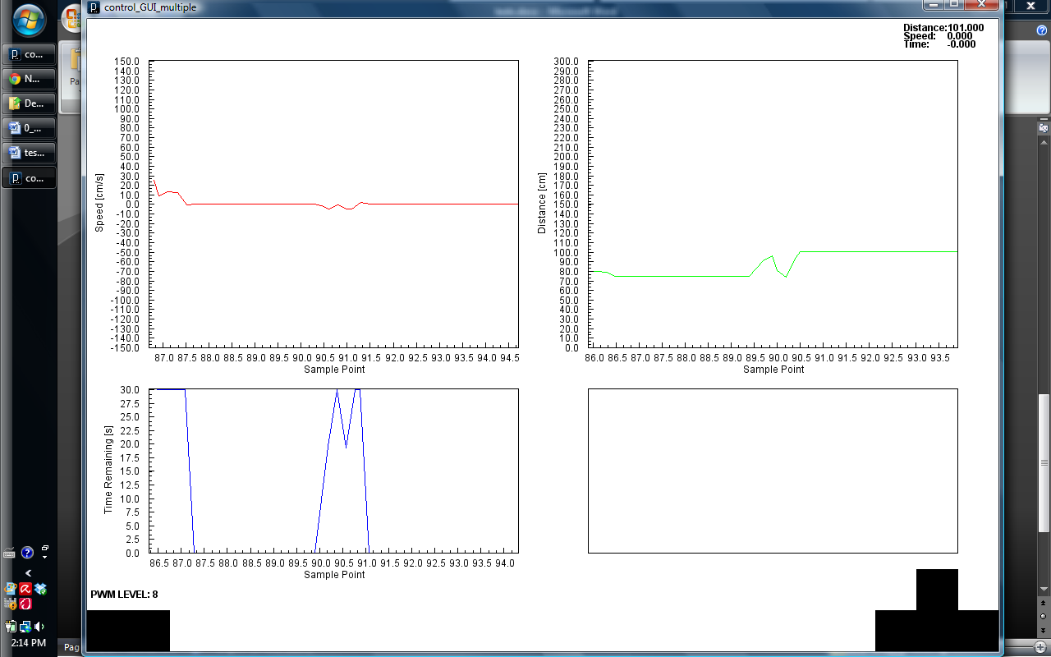

2m

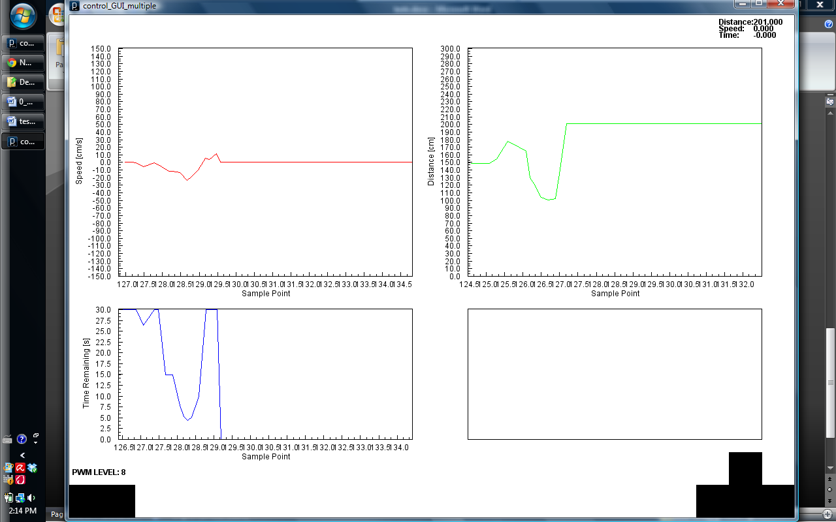

3m

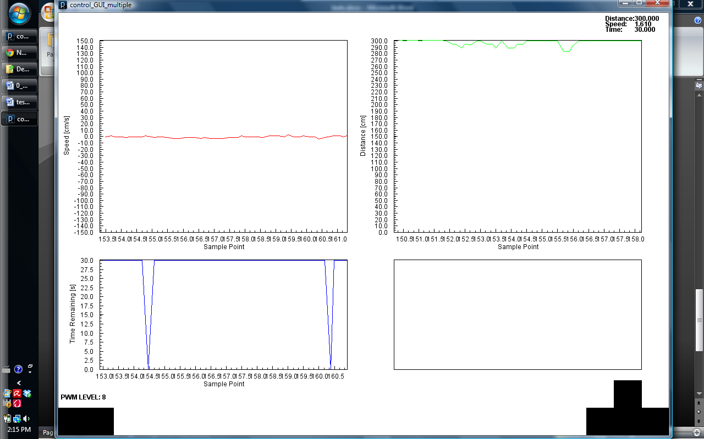

Speed Tests:

Obstacle Approaching 1

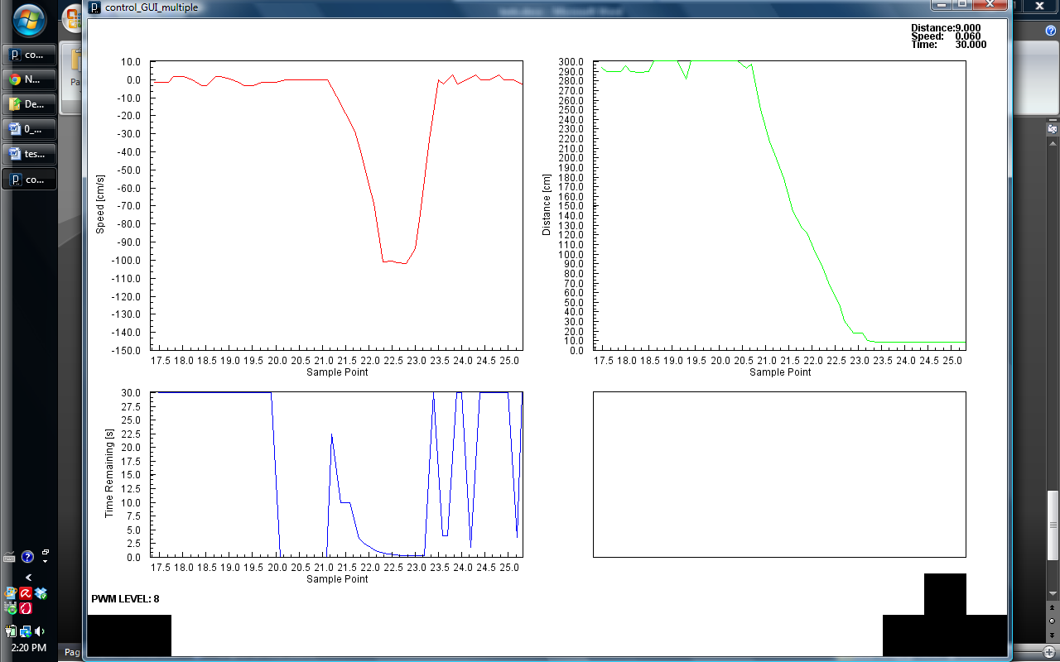

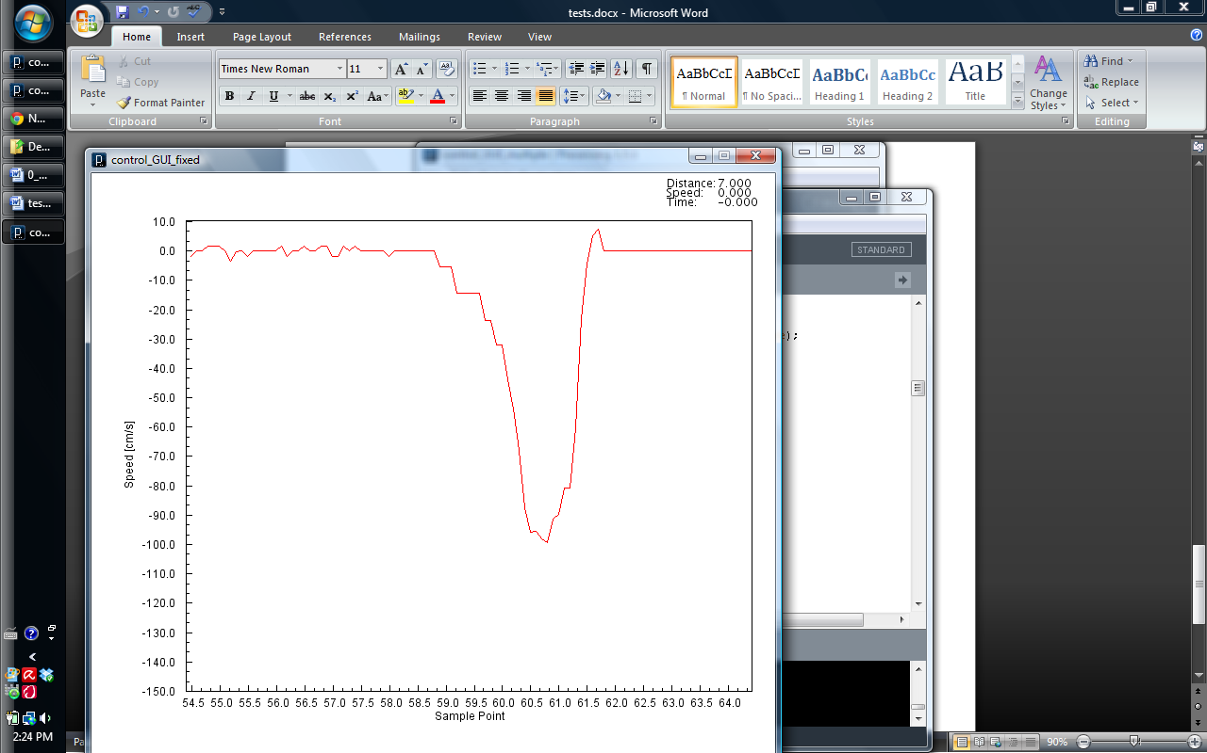

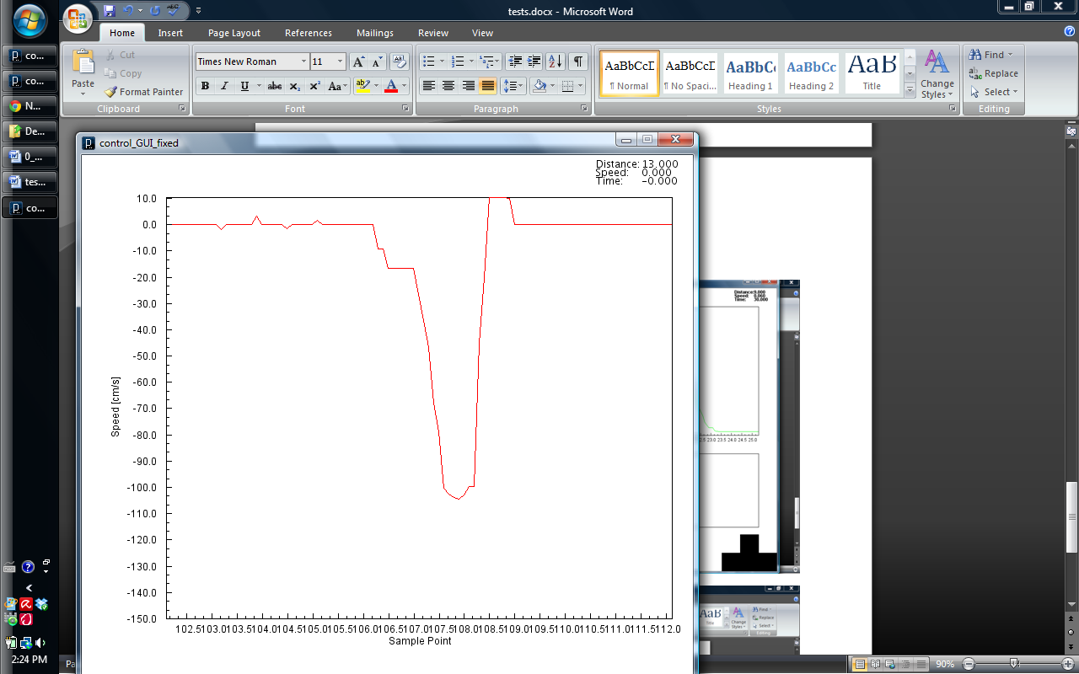

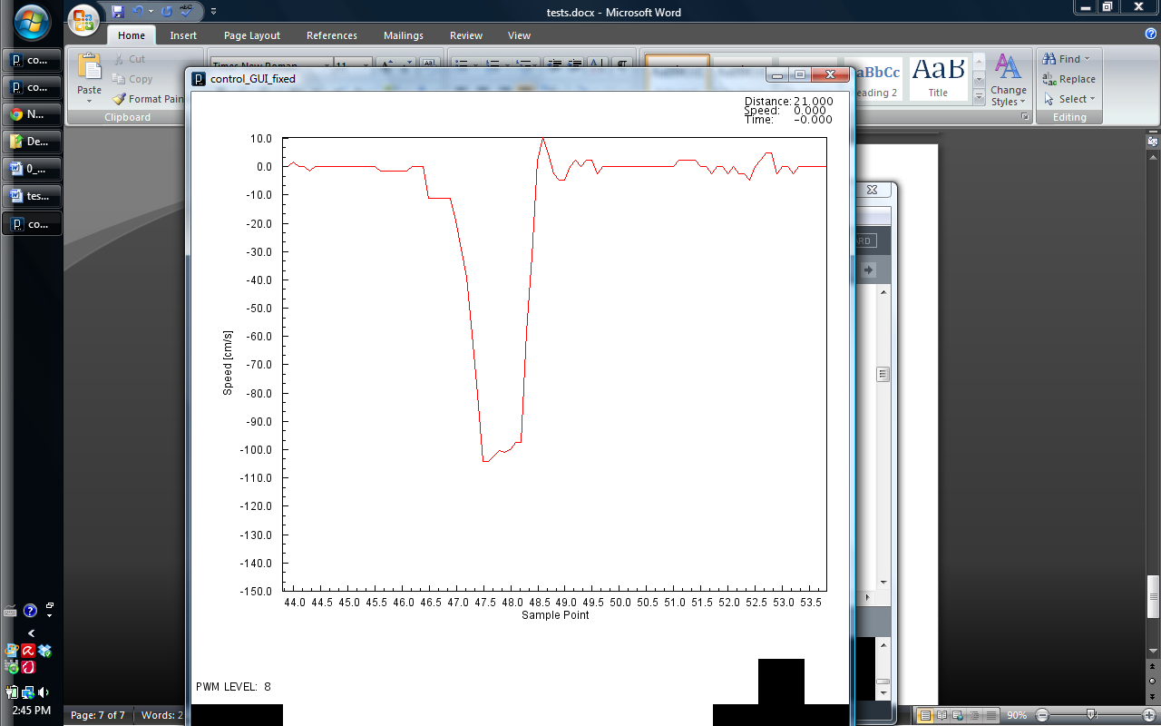

Car moving away

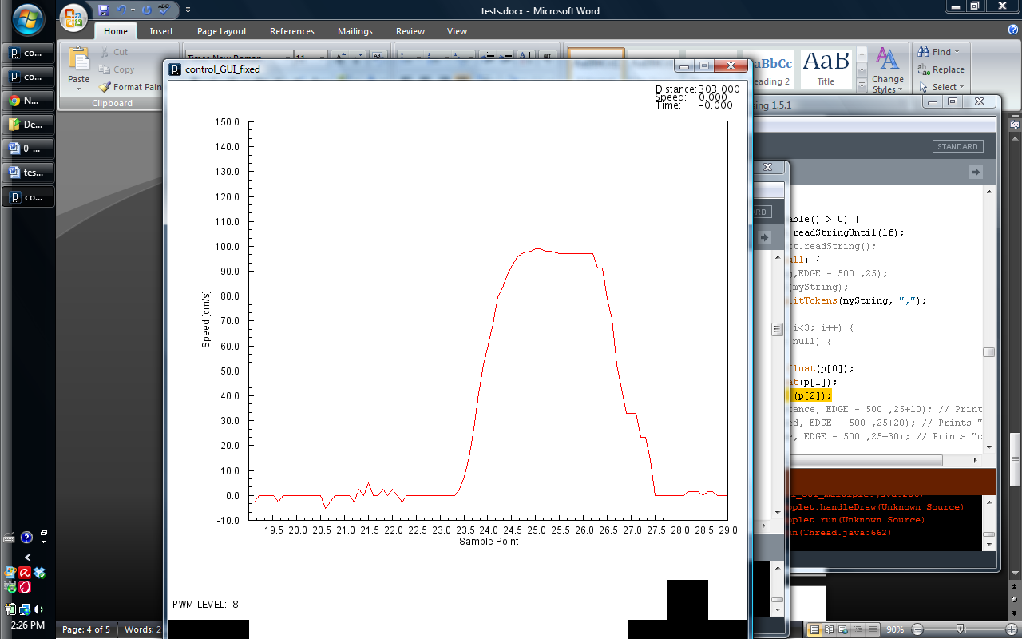

94cm/s

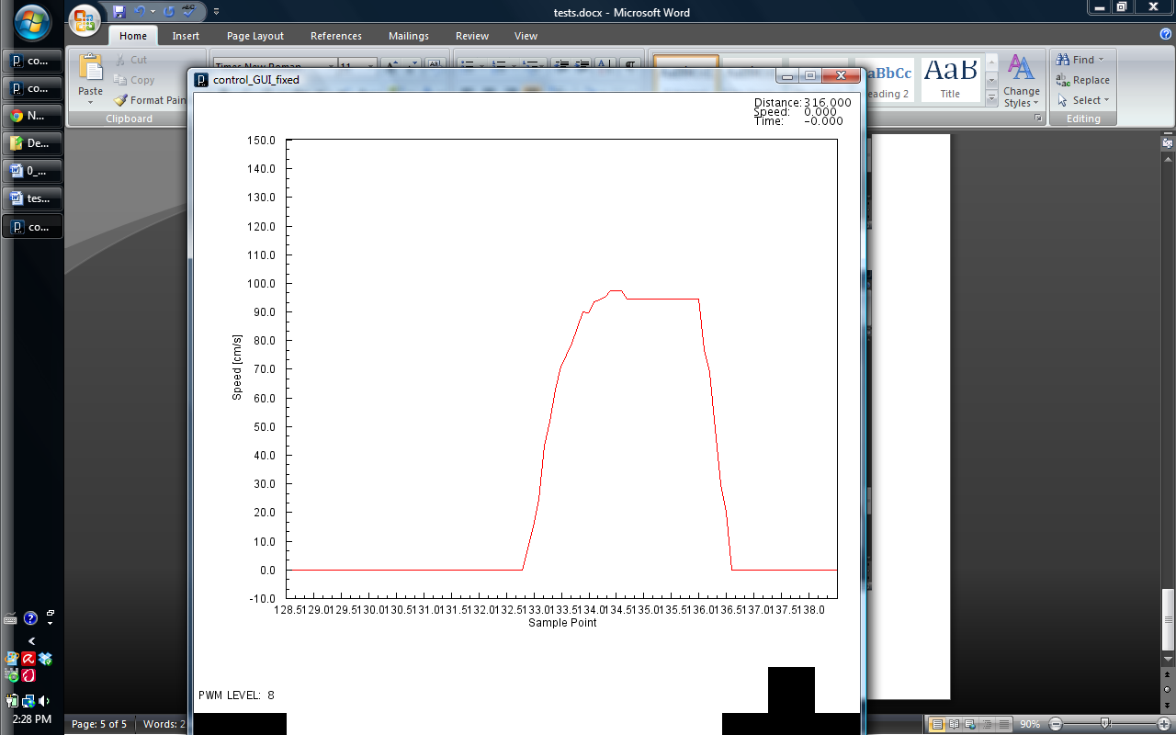

89.5 cm/s

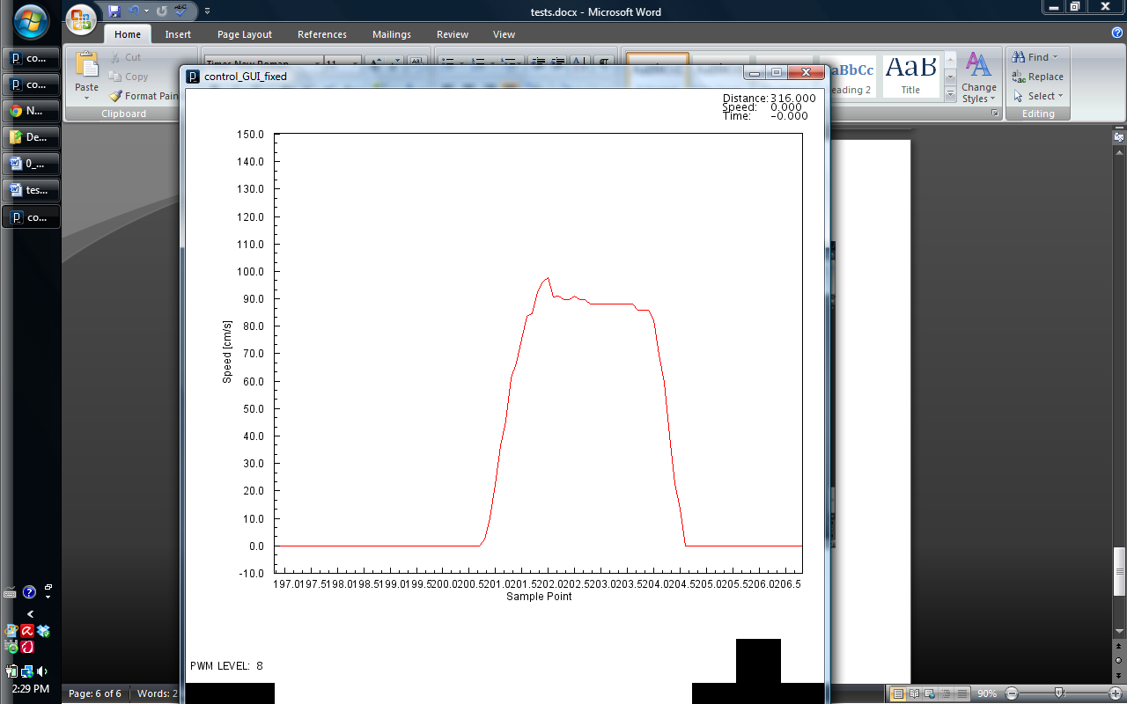

94cm/s

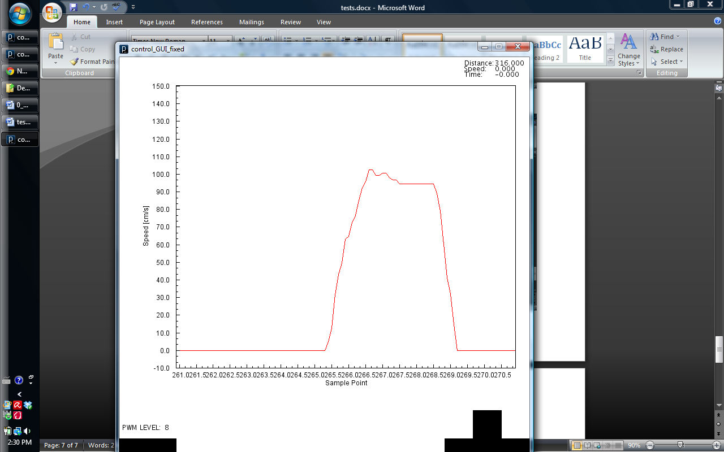

Car Approaching

101cm/s

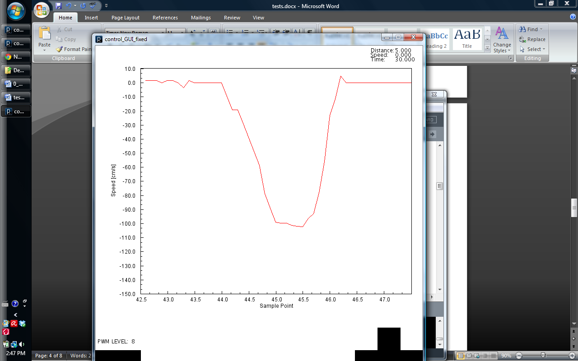98cm/s

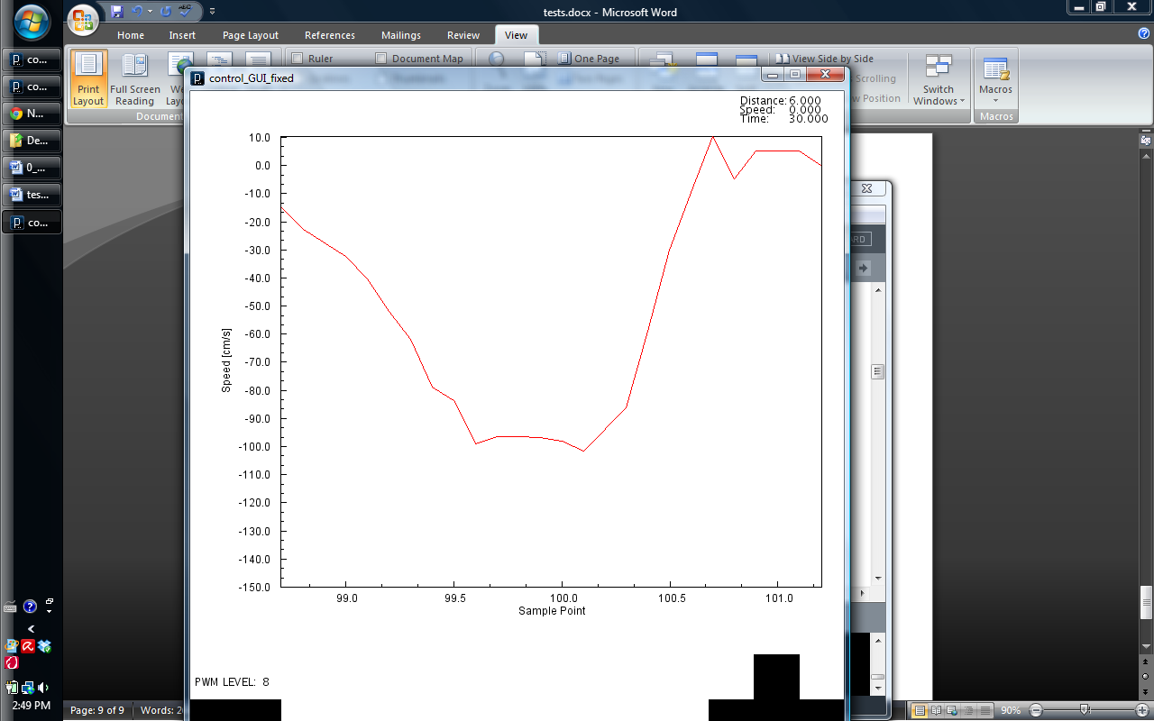

104cm/s

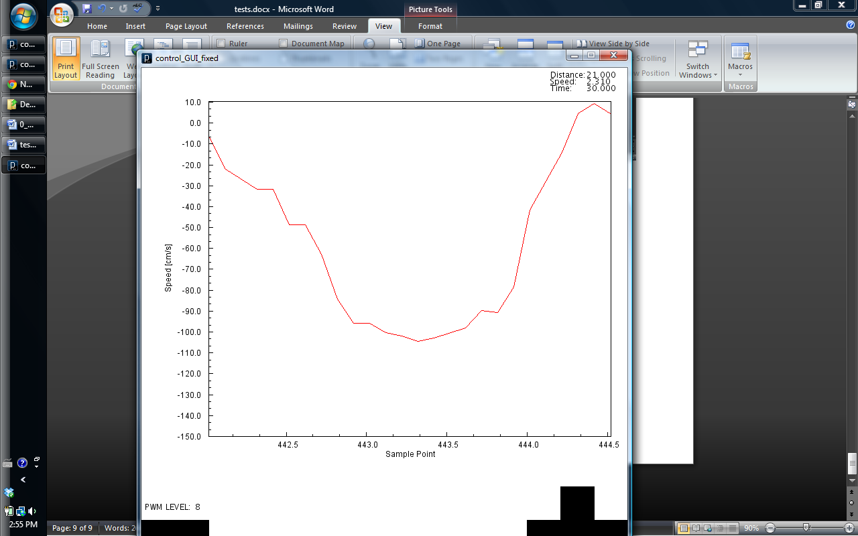

104 cm/s

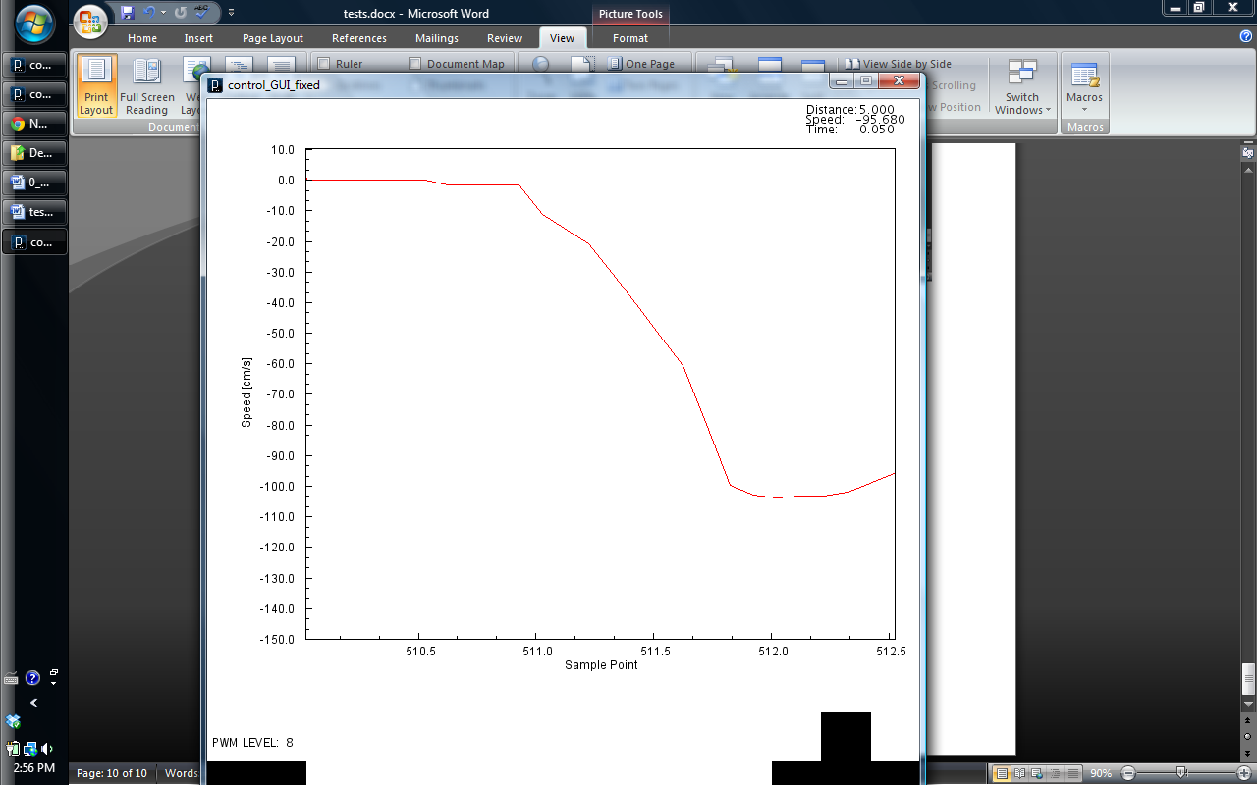

Prelim Rel Speed

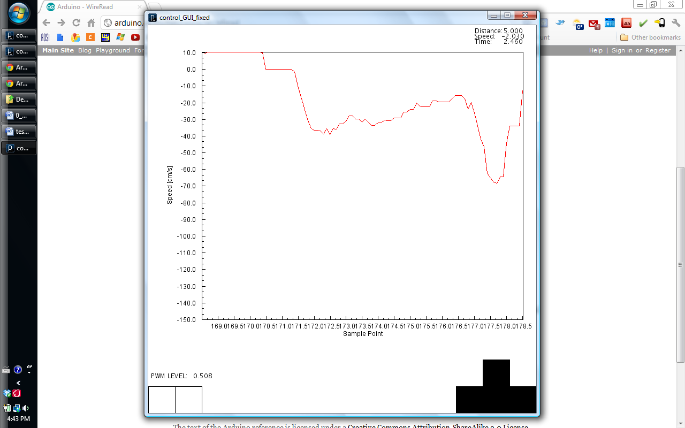

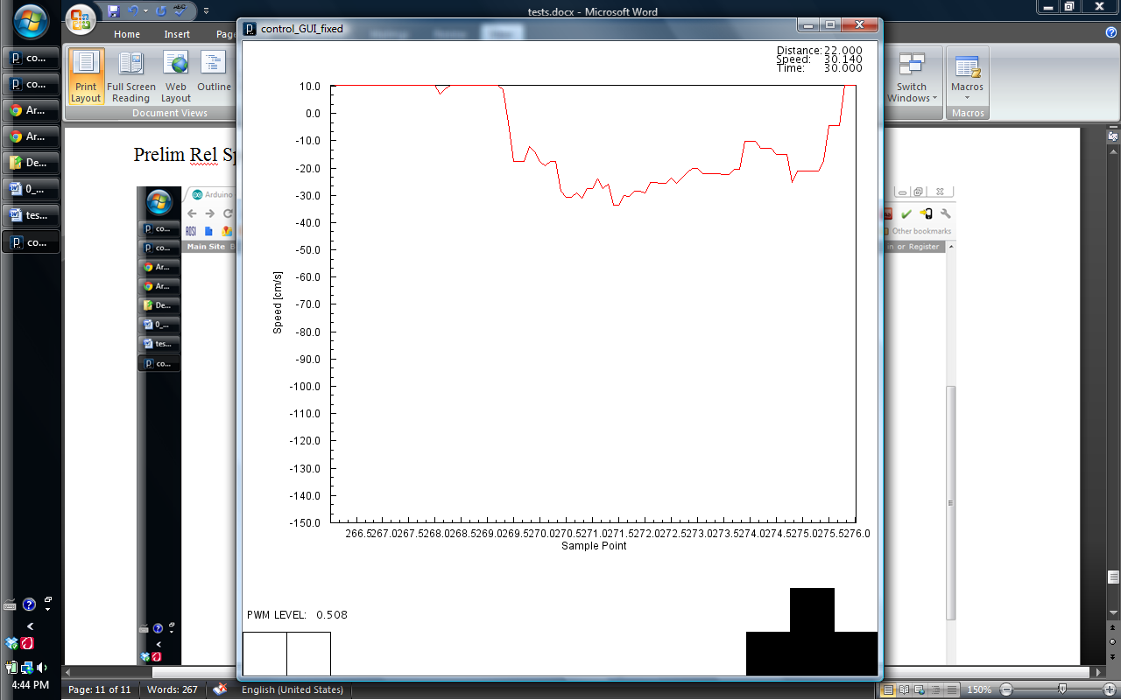

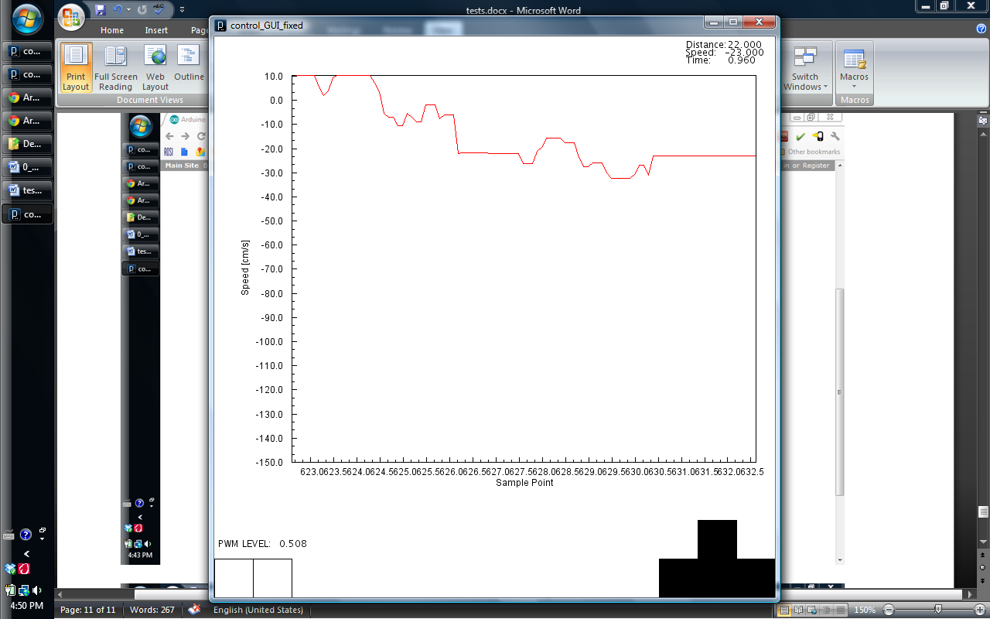

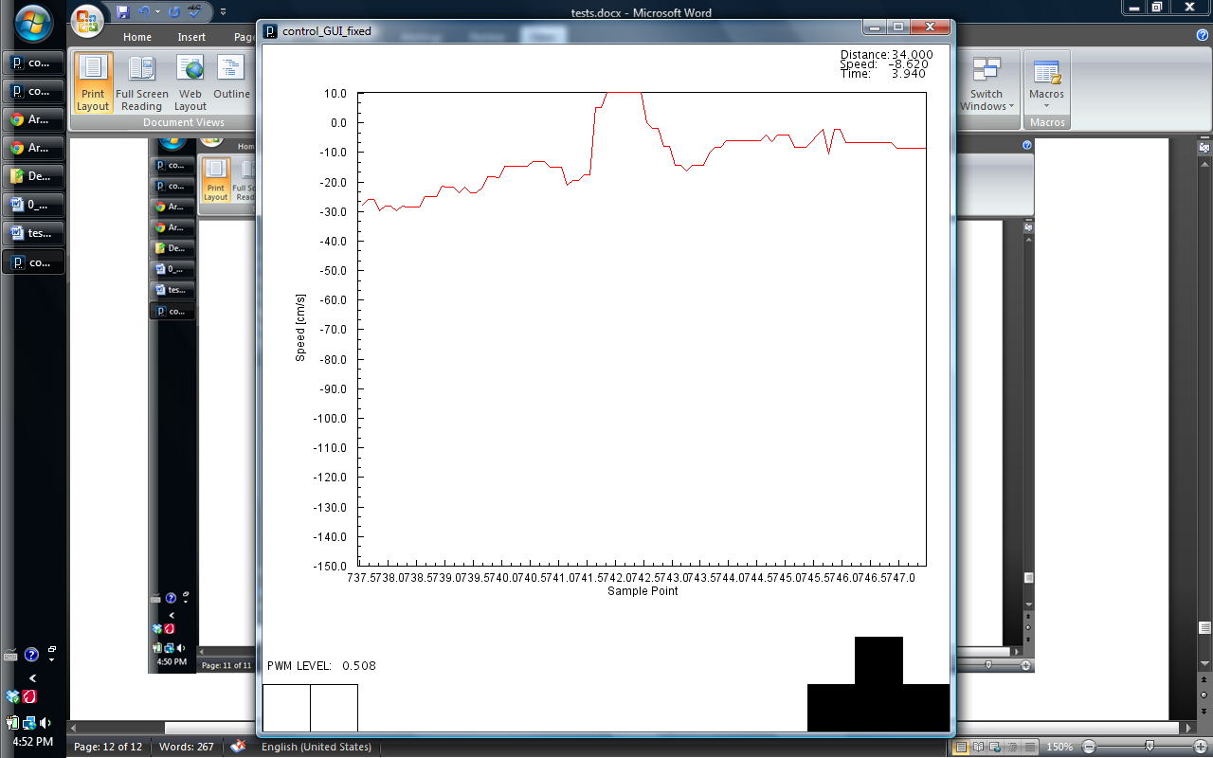

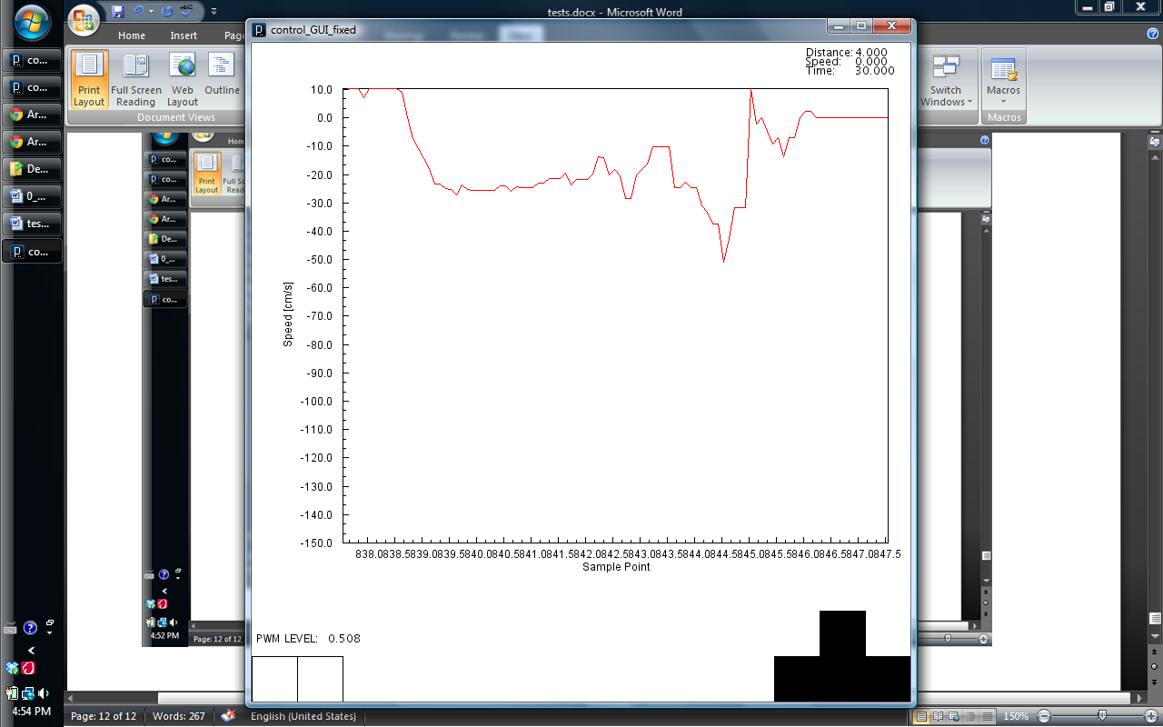

Relative Speed Tests

New Sensor Placement

PWM: 49.2%

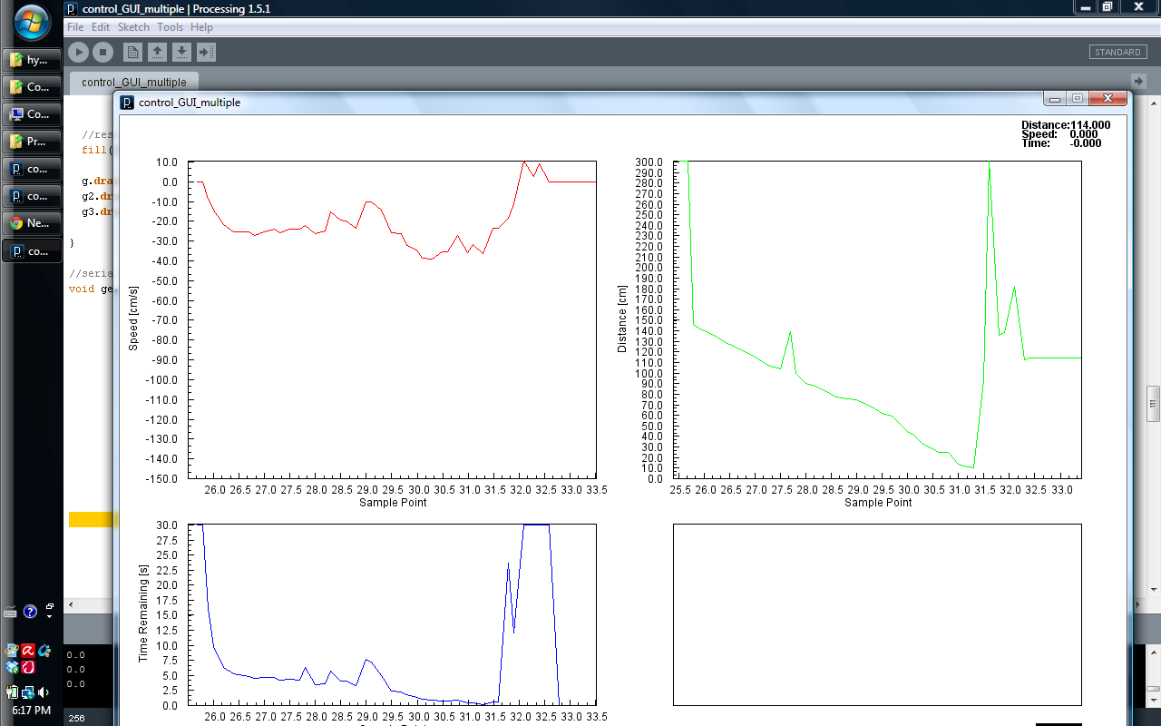

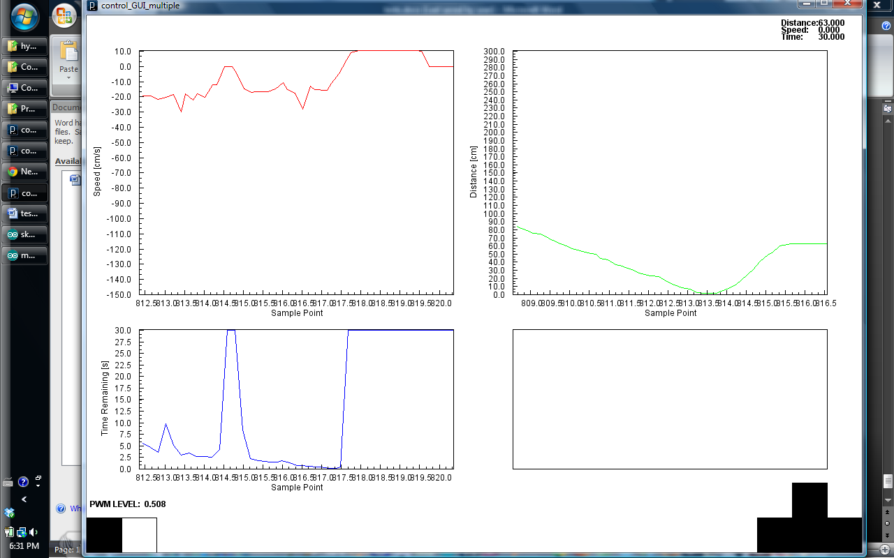

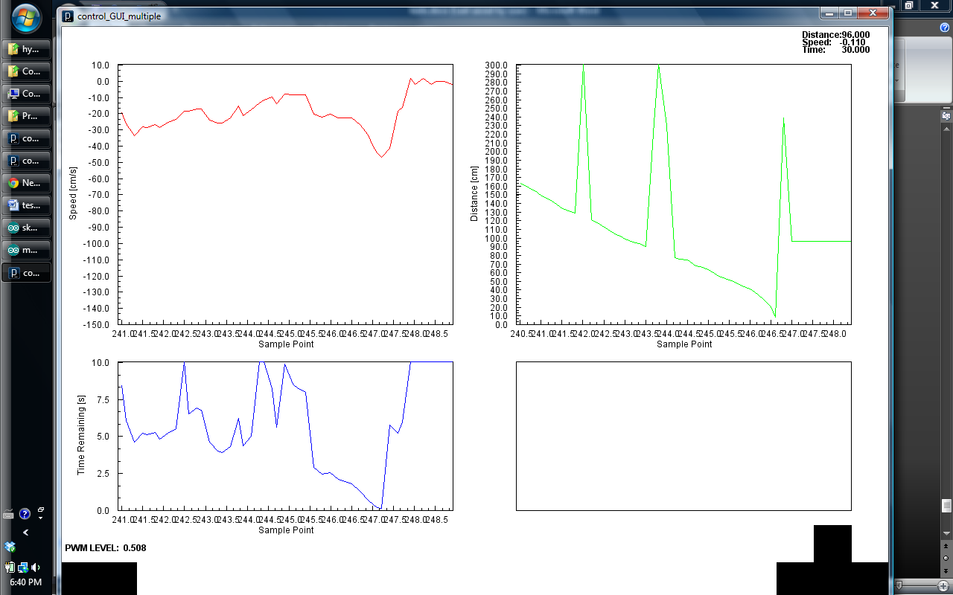

For Report:

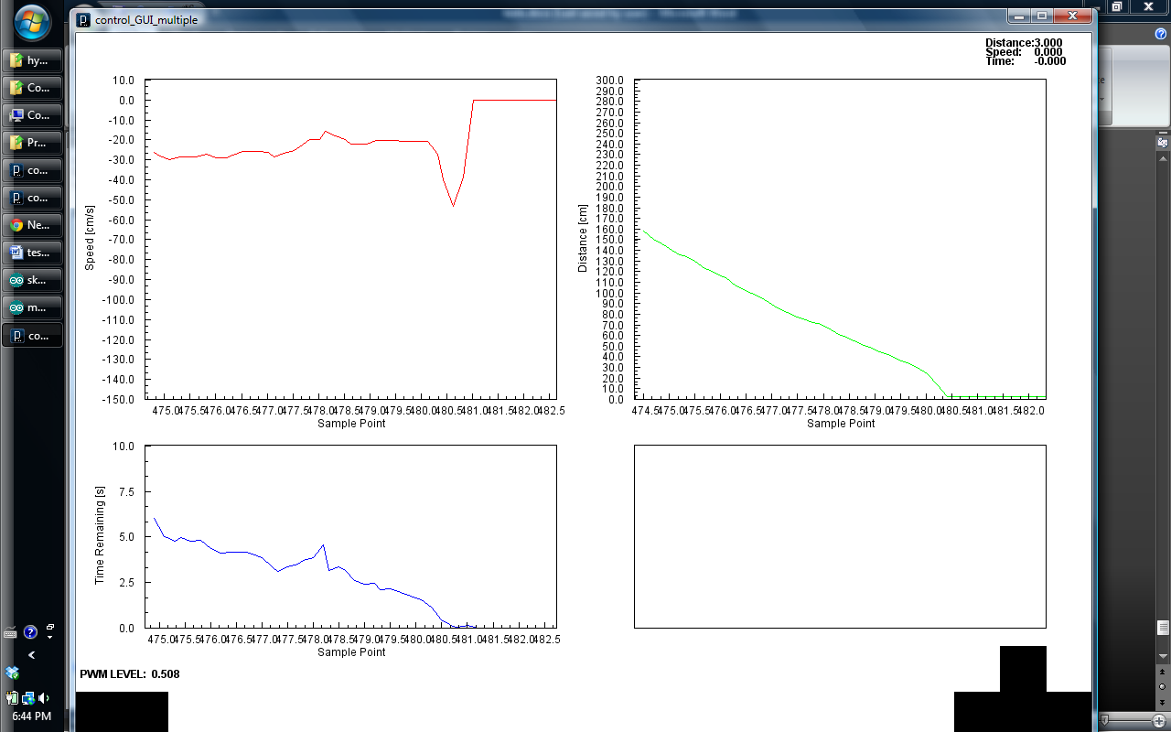

Black car

6m track

T1: 5.7 s 105 cm/s

T2: 5.6 s 107 cm/s

Avg: 106 cm/s

Yellow Car:

T1: 6.9s 87 cm/s

T2: 7.2s 83 cm/s

Avg: 85 cm/s

Rel: 21cm/s

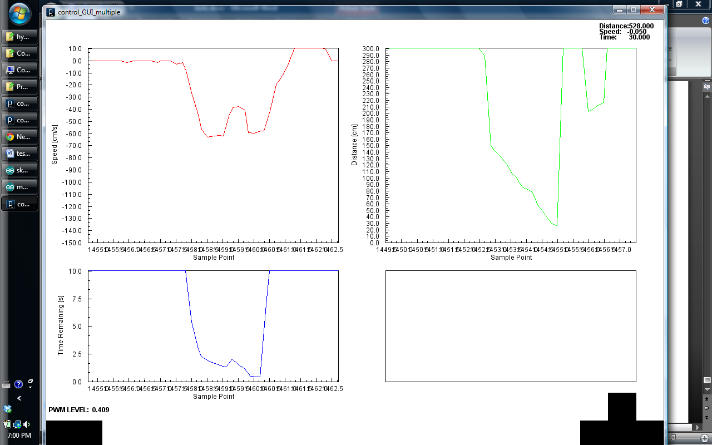

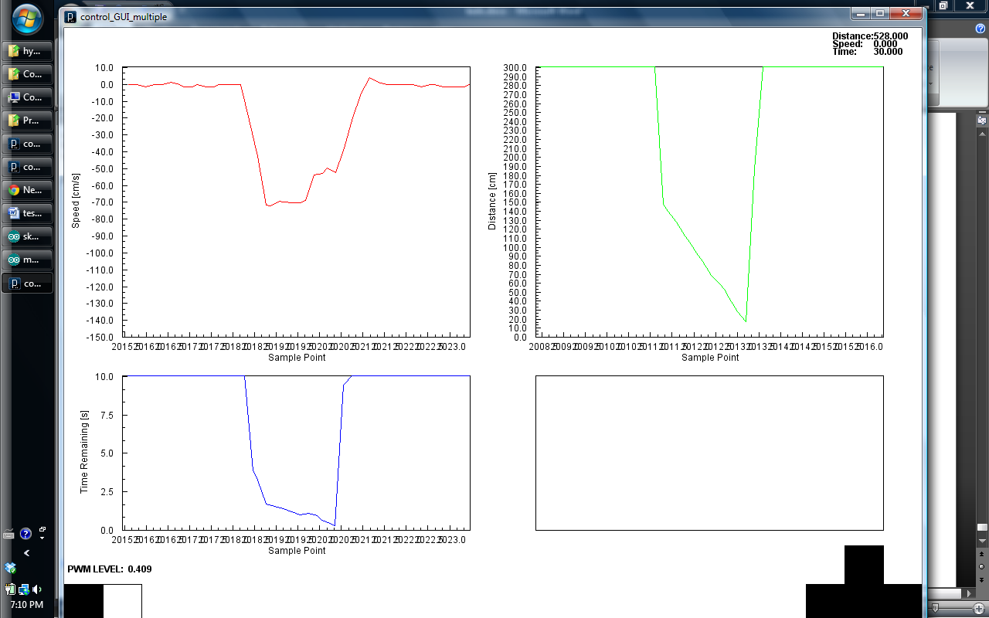

Yellow Car:

T1: 21 s 28cm/s

T2: 23

Delta: 77 cm/s

For Report

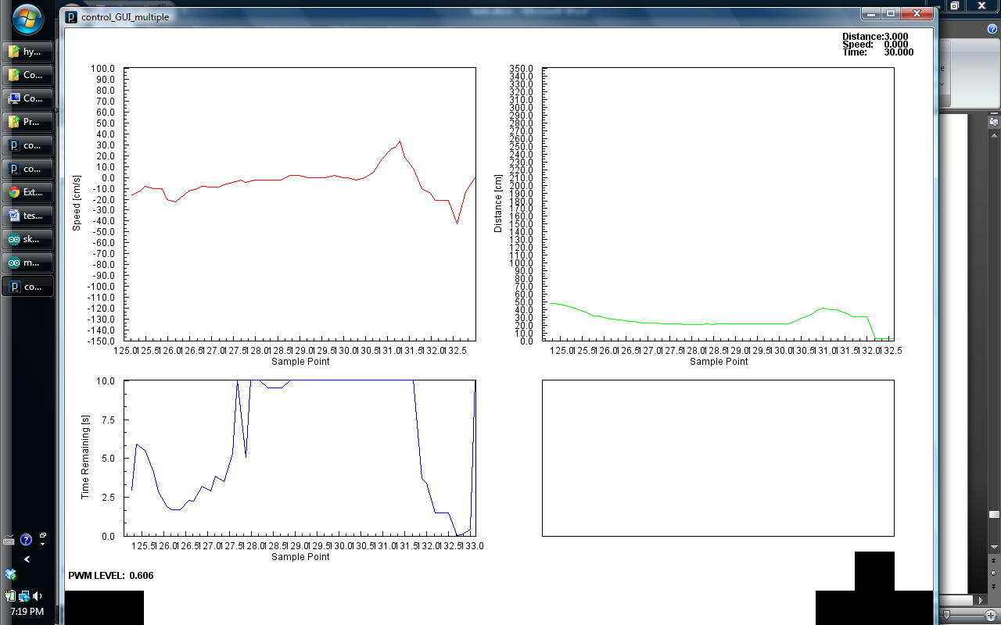

Yellow Car:

T1:5.7 105cm/s

T2: 5.8

Delta: 0cm/s